**- AON Network Diagram**

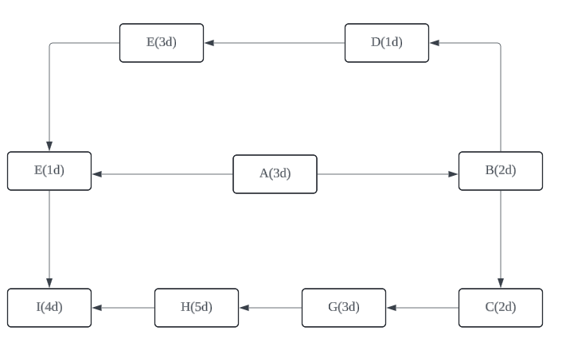

**- Possible paths through the diagram and their durations:**

Three paths:

1. Path: A → B → C → G → H → I, Duration: 19 days
2. Path: A → B → D → E → F → I, Duration: 14 days
3. Path: A → F → I, Duration: 8 days

**- Critical Path:**

A → B → C → G → H → I, with a total duration of 19 days. This is the path that dictates the minimum time required to complete the project.